**Patrick Rowlee and Charles Ambaiowei**

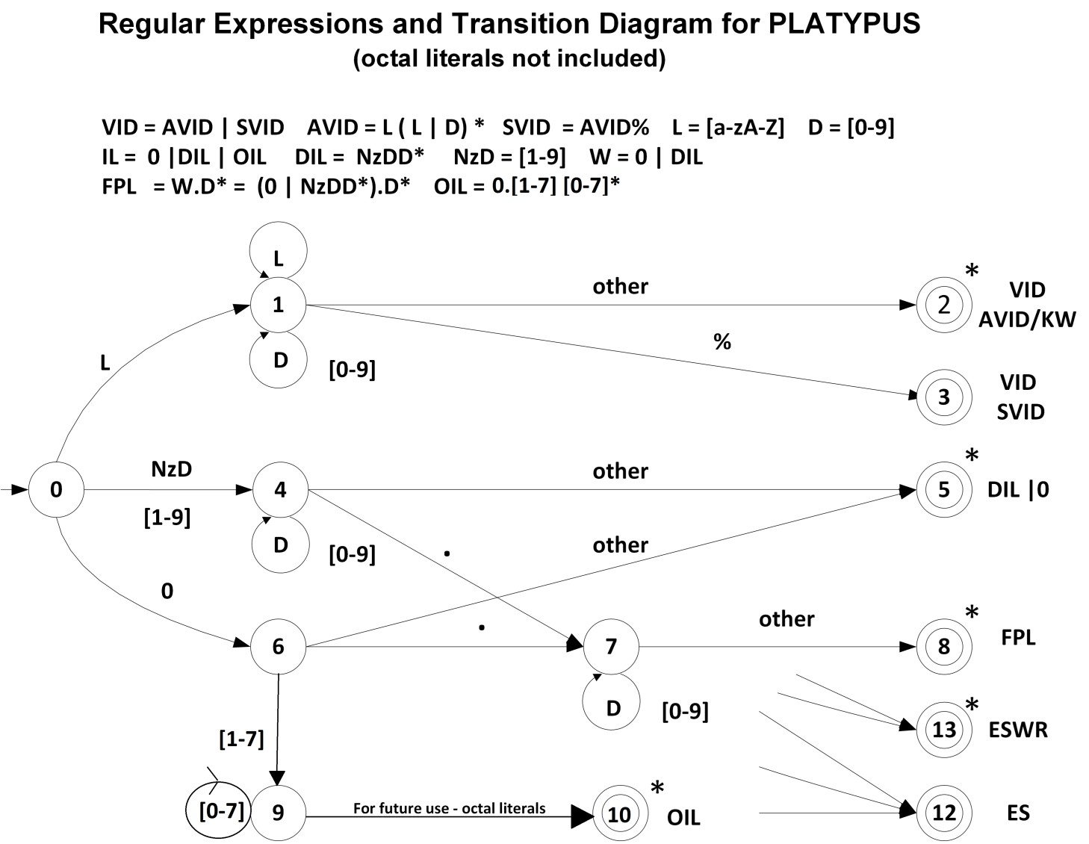

**Transition Table**

|  |  |  |  |  |  |  |  |  |  |
| --- | --- | --- | --- | --- | --- | --- | --- | --- | --- |
| **Current State** |  |  |  | **INPUT SYMBOL** | | |  |  | **State Type**  **(Not Accepting or Accepting State)** |
| **[a-zA-z]** | **0** | **[1-7]** | | **[8-9]** | **.** | **%** | **other** |
| **0** | **1** | **6** | **4** | | **4** | **IS** | **IS** | **IS** | **NOAS** |
| **1** | **1** | **1** | **1** | | **1** | **2** | **3** | **2** | **NOAS** |
| **2** | **IS** | **IS** | **IS** | | **IS** | **IS** | **IS** | **IS** | **VID AVID/KW - ASWR** |
| **3** | **IS** | **IS** | **IS** | | **IS** | **IS** | **IS** | **IS** | **VID SVID - ASNR** |
| **4** | **ES** | **4** | **4** | | **4** | **7** | **5** | **5** | **NOAS** |
| **5** | **IS** | **IS** | **IS** | | **1S** | **IS** | **IS** | **IS** | **DIL - ASWR** |
| **6** | **ES** | **ES** | **9** | | **ES** | **7** | **ES** | **5** | **NOAS** |
| **7** | **8** | **7** | **7** | | **7** | **8** | **8** | **8** | **NOAS** |
| **8** | **IS** | **IS** | **IS** | | **IS** | **IS** | **IS** | **IS** | **FPL - ASWR** |
| **9** | **10** | **9** | **9** | | **ES** | **ES** | **10** | **10** | **NOAS** |
| **10** | **IS** | **IS** | **IS** | | **IS** | **IS** | **IS** | **IS** | **OIL-ASWR** |
| **11** | **IS** | **IS** | **IS** | | **IS** | **IS** | **IS** | **IS** | **NOAS** |
| **12** | **IS** | **IS** | **IS** | | **IS** | **IS** | **IS** | **IS** | **ES - ASNR** |
| **13** | **IS** | **IS** | **IS** | | **IS** | **IS** | **IS** | **IS** | **ESWR - ASWR** |

**IS** – **I**llegal **S**tate **ES** – **E**rror **S**tate **E/A** – **E**rror State or **A**ccepting State

**NOAS – No**t **A**ccepting **S**tate

**ASWR** - **A**ccepting **S**tate **W**ith **R**etract **ASNR** - **A**ccepting **S**tate **N**o **R**etract

CST8152-Compilers, A2, F16